**JOBSHEET 3**

**SELECTION SORT**

**TUGAS 1**

package Selectionsort;

import java.util.Scanner;

public class Tugas1 {

public static void main(String[] args) {

int[] data = new int[10];

Scanner baca = new Scanner(System.in);

int i, temp,pos, min, n = data.length;

System.out.println("Selection Sort");

for(i = 0; i < data.length; i++)

{

System.out.print("Masukkan Elemen ke- " + (i+1) + ":");

data[i] = baca.nextInt();

}

System.out.println("");

System.out.println("Sebelum Di Urutkan: ");

for (i=0; i < data.length; i++) {

System.out.print(data[i] + "" + ",");

}

System.out.println("");

System.out.println("");

for(pos = 0; pos < n - 1; pos++)

{

min = pos;

for(i = pos + 1; i < n; i++)

{

if(data[i] < data[min])

{

min = i;

}

}

temp = data[min];

data[min] = data[pos];

data[pos] = temp;

System.out.print("Step " + (pos + 1) + ": ");

for (i=0; i < data.length; i++)

{

System.out.print(data[i] +" ");

}

System.out.println("");

}

System.out.println("");

System.out.println("Setelah Di Urutkan: ");

for (i=0; i < data.length; i++) {

System.out.print(data[i] +" ");

}

System.out.println("");

}

}

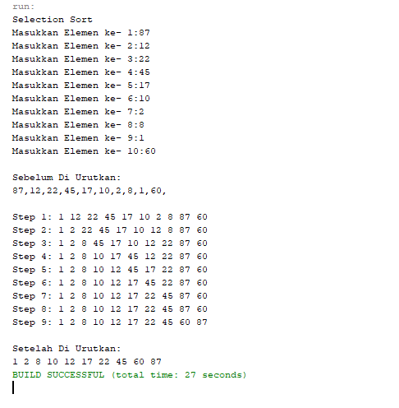

**TUGAS 2**

package Selectionsort;

import java.util.Scanner;

public class Tugas2 {

public static void main(String[] args) {

int[] data = new int[10];

Scanner baca = new Scanner(System.in);

int i, temp,pos, min, n = data.length;

System.out.println("Selection Sort");

for(i = 0; i < data.length; i++)

{

System.out.print("Masukkan Elemen ke- " + (i+1) + ":");

data[i] = baca.nextInt();

}

System.out.println("");

System.out.println("Sebelum Di Urutkan: ");

for (i=0; i < data.length; i++) {

System.out.print(data[i] + "" + ",");

}

System.out.println("");

System.out.println("");

for(pos = 0; pos < n - 1; pos++)

{

min = pos;

for(i = pos + 1; i < n; i++)

{

if(data[i] > data[min])

{

min = i;

}

}

temp = data[min];

data[min] = data[pos];

data[pos] = temp;

System.out.print("Step " + (pos + 1) + ": ");

for (i=0; i < data.length; i++)

{

System.out.print(data[i] +" ");

}

System.out.println("");

}

System.out.println("");

System.out.println("Setelah Di Urutkan: ");

for (i=0; i < data.length; i++) {

System.out.print(data[i] +" ");

}

System.out.println("");

}

}

